EC-231 Operating Systems
BS(CE)-2021
LAB REPORT # 08

Submitted By:
Reg. No. | Name
21-CE-009 | Huzaifa Shahbaz
21-CE-021 | Yawar Ali Malik
21-CE-020 | Muhammad Ibthesam

Department of Computer Engineering
BS Computer Engineering Program
HITEC University Taxila
 | Presentation  (Format (0.5) + Title (0.5) +  Conclusion(1) + Procedure(2) + Objective(1)) | Calculation/Coding | Observation/ Program Results | Total
Total | 5 | 5 | 5 | 15
Obtained

___________________________
Lab Instructor.
Engr. Fasih Ahmad
Experiment # 08
Process related System Calls in Linux
Objective
In this lab we will learn about system call techniques i.e.
• fork()
• exit()
• wait()
• exec()
Software Used
Virtual Box
Ubuntu
Procedure
- Using fork() and exit():
Open gedit editor.
Write a suitable command to create a child process using fork() and execute a command.
Implement the child process to execute a command.
Use exit() to gracefully terminate the child process.
Save and run the script to observe the execution.
- Using wait() and exit():
Open gedit editor.
Write a suitable command to create a child process using fork() and execute a command.
Implement the parent process to wait for the child process to complete using wait().
Use exit() to gracefully terminate both parent and child processes.
Save and run the script to observe the execution.
- Task 3
Open gedit editor.
Write C code based on Algorithm 1:
Declare variables.
Implement parent and child processes using fork().
Print process IDs and statuses.
Exit both processes.
Write C code based on Algorithm 2:
Declare variables.
Print a “Hello World”.
Implement parent and child processes using fork().
Print process IDs and statuses.
Gracefully exit both processes.
Save and compile the C programs.
Tasks
Task 1
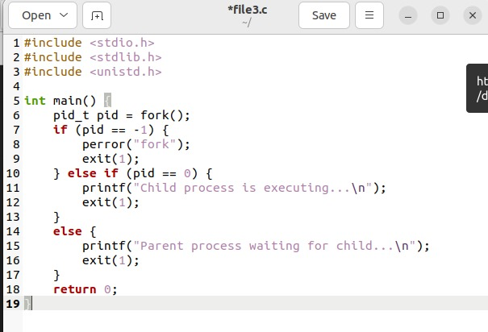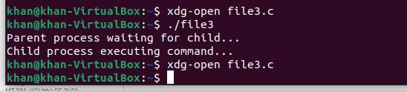
Task 2
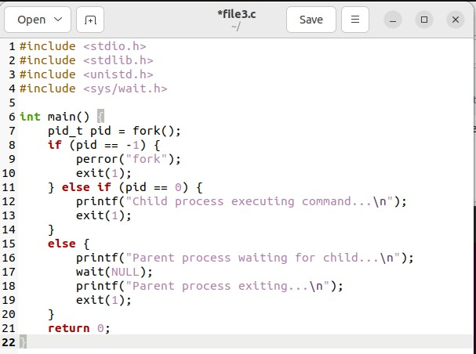
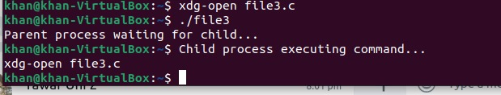
Task 3
Algorithm 1:
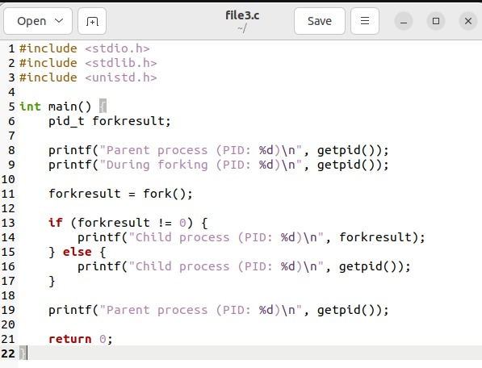
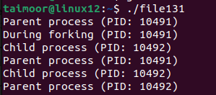
Algorithm 2:
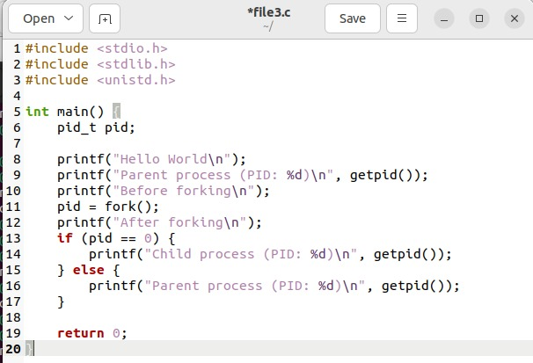
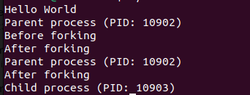
Conclusion
In this lab, we delved into the features of wait(), fork(), and exit() system calls, enriching our comprehension of process control. By mastering the art of coordinating processes, creating child processes, and overseeing their completion, we've refined indispensable competencies essential for crafting resilient Unix-oriented applications.

